UNIT II POLYMERS PART A
1. Write the classification of polymers. (Jan 14)
Classification of Polymers

Origin Thermal response Mode of formation Form and use Tacticity
Natural Thermoplastic Addition Plastic Atactic
Semi-Synthetic Thermosetting Condensation Elastomer Isotatic
Synthetic Fiber Syndiotactic
2. Distinguish between addition and condensation polymerization.
Addition / Chain polymerization | Condensation / Step polymerization
(i) Monomers add on to give a polymer and no other by-product is formed  (ii) Homochain polymer is produced  (iii) Thermoplastics are produced.  E.g. Polyethylene and PVC. | Monomers condense to give polymer with byproducts such as H₂O and HCI  Heterochain polymer is produced  Thermosetting plastics are produced.  E.g. Bakelite and polyester.
3. Calculate degree of polymerization of polypropylene of molecular weight of 84,000 g/mol. (Jan 15)
Molecular weight of polymer (Mw) 84000
Degree of polymerization (Dp) = = = 1996
Molecular weight of monomer (M) 42.08
4. What are free radical initiators? Give example. (Jan 14, May 14)
Free radical initiators
The compounds which readily decompose into free radicals so that monomer molecules can interact with these free radicals for their activation are called free radical initiators.
E.g. Benzoyl peroxide.
5. Write note on number and weight average molecular weight of polymer. (May 13)
Number average molecular weight
M_{n} = Σn_{i}M_{i} / Σn_{i}
It is determined by osmotic pressure.
Weight average molecular weight
M_{w} = n_{i}M_{i}² / Σn_{i}M_{i}
It is obtained from light scattering method.
6. Write short note on Chemical resistance of polymers. (May 16)
Chemical resistance of polymers
Chemical nature of monomeric units and their molecular arrangement determines chemical resistance of polymers. Usually the attack is internal, causing softening, swelling and loss of strength of material. A polymer is more soluble in structurally similar solvent.
Example
Polymers containing polar group (OH and COOH) are dissolved in polar solvents (alcohol). Polymers having non-polar groups (methyl and phenyl) are dissolved in non-polar solvents (benzene).
7. What is glass transition temperature? (Jan 13)
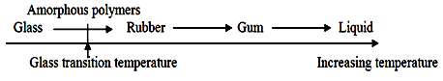
Glass transition temperature (Tg)

When polymer is heated, it eventually softens and becomes more flexible which is called as glass transition temperature (Tg).
Amorphous polymers do not possess melting points but posses softening point. Amorphous solid tends to shatter if it is hit, because molecular chains cannot move at all easily.
8. Give the preparation and uses of PVC and TEFLON.
Preparation of Poly Vinyl Chloride (PVC)
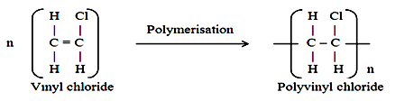

PVC is produced by heating vinyl chloride in presence of benzoyl peroxide catalyst in an autoclave under pressure.
Vinyl chloride so-needed is prepared by treating acetylene with hydrogen chloride.

Uses of PVC
- Plasticized PVC for rain coats, table cloths and toys.
- Rigid PVC for helmets and refrigerator components.
Preparation of TEFLON
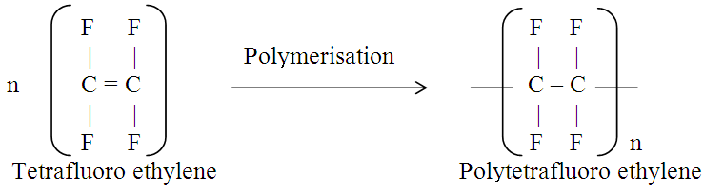

Teflon is obtained by polymerization of tetrafluoro ethylene under pressure in presence of benzoyl peroxide as catalyst.
Tetrafluoro ethylene can be prepared from chloroform and hydrofluoric acid.
CHCl₃ + HF CF₂ = CF₂
Uses of TEFLON
For making insulating materials, gaskets, burette stop-cocks and non–stick pans.
9. Give the preparation and uses of Nylon 6 and Nylon 11. (Nov 10, May 11)
Preparation of Nylon 6
n H₂N - (CH₂)₅ - COOH [ HN - (CH₂)₅ – CO ]_{n}
ε-amino caproic acid - H₂O Nylon 6
Nylon-6 is produced by self condensation of ε-amino caproic acid.
Uses of Nylon 6
For gears, bearings and electrical mountings.
Preparation of Nylon 11
H₂N - (CH₂)₁₀ - COOH [ HN - (CH₂)₁₀ – CO ]_{n}
ω-amino undecanoic acid - H₂O Nylon 11
Nylon 11 is obtained by self condensation polymerization of ω-amino undecanoic acid.
Uses of Nylon 11
For making tyres and watch straps.
10. List the drawbacks of raw rubber.
Drawbacks of raw rubber
- Raw rubber is soft at high T and brittle at low T and can be used at 10 to 60º C only.
- It is weak and has large water–absorption capacity.
- When two rubber surfaces are pressed, it form a single piece (tackiness).
- When stretched to a great extent, it suffers permanent deformation.
11. Give the preparation and uses of Polyurethane and Nitrile rubber. (Jan 15, May 15)
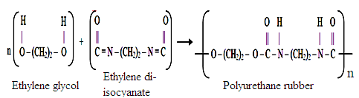
Preparation of Polyurethane

Polurethene rubber (or isocyanate rubber) is produced by reacting polyalcohol with di-isocyanates.
Uses of Polyurethane
For manufacture of foams and spandex fibres.
Preparation of Nitrile rubber
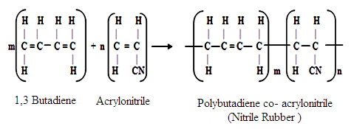

Nitrile or Buna-N rubber is a copolymer of butadiene and acrylonitrile.
Uses of Polyurethane
For making conveyor belts, aircraft components, gaskets and automobile parts.
12. What is Fiber Reinforced Plastics (FRP)? Give examples.
Fiber Reinforced Plastics (FRP)
Combination of polymeric substance with solid fillers is called Fiber Reinforced Plastics.
Filler acts as reinforcing material; while polymer acts as binder. Polymer serves as stress transforming agent from filler to filler particles.
Example
Wood flour, saw dust, ground cork, china clay and paper pulp.
13. Write note on Laminar composites and its types.
Laminar composites
Laminate is a product obtained by joining two or more layers of solid materials.
If grains of laminates are parallel to each other, it is called parallel laminate and if grains are arranged at right angles to others, it is called cross-laminate.
Example
Plywood, Laminated plastics, Laminated glass and Thermocole.

14. Give the preparation, properties and uses of Silicone rubbers.
Preparation of Silicone rubber
Silicone rubber is produced by reacting silicon halide with Grignard reagent.
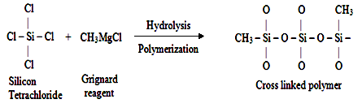

Uses of Silicone rubber
- As sealing materials in aircrafts engine and search lights.
- As adhesive in electronic industry and for making artificial heart valves.

15. Write note on moulding constituents of plastic. (Jan 15, May 15)
Moulding constituents of plastic
Resin - holds different constituents together
Plasticizer - increase their plasticity and flexibility
Filler - give better hardness and tensile strength
Lubricant - make moulding process easier and give glossy finish
Catalyst - added to thermosetting resins to accelerate formation of cross linkages
Stabilizer - improve thermal stability
Colours - increase market appeal and attractive finish.

PART - B
1. Explain various types of polymerization. (Nov 10, May 11)
Types of polymerization
Three kinds of polymerization are addition, condensation and Copolymerization.
- Addition or Chain polymerization
This involves addition of monomers to one another to form a long polymer chain with exact multiple of original monomer.
Double bond of monomer is broken by heat, pressure or catalyst and monomers add to form a linear polymer chain.
It generally produces thermoplastic polymers with no byproduct.
Example
Polyethylene is produced from ethylene by addition polymerization.
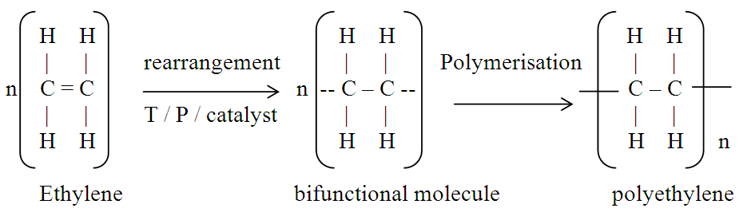

- Condensation or Step polymerization
Reaction between polar group containing monomers (hydroxyl, carbonyl, amino groups) to form polymer with elimination of small molecules like water and HCI, is called condensation polymerization.
This occurs, only if monomers contain at least two reactive functional groups (same or different).
Example
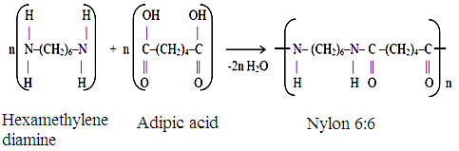
Hexamethylene diamine and adipic acid condense to form Nylon 6:6.

- Copolymerization
Copolymerization is joint polymerization with two or more different monomers combine to give polymer.
It is mainly carried out to vary properties of polymers such as hardness, rigidity, flexibility and heat resistant nature of polymer.
Example
Butadiene and Styrene copolymerize to give GR-S rubber.
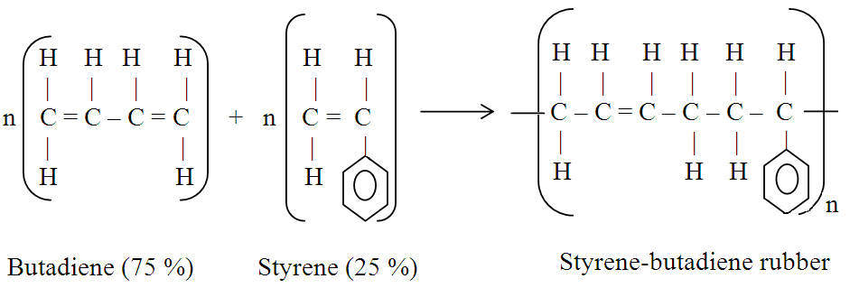

2. Explain Free - Radical polymerization mechanism. (Jan 11, 15, May 12, 13, 16)
Free - Radical polymerization mechanism
It consists of three major steps, initiation, propagation and termination.
Initiation of polymer chain growth is brought by free radicals produced by decomposition of compounds called initiators.
Chain growth represents a process involving a continuous and very rapid addition of monomer units to form polymer chains.
Initiation
First step is the production of free radicals, usually by homolytic dissociation of an initiator to yield a
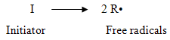
pair of radicals R•.

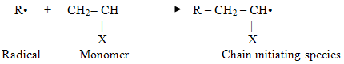
Next involves addition of this radical to first monomer molecule to produce chain initiating species.

Propagation
This step consists of growth of chain initiating species by successive additions of large numbers of monomer molecules.
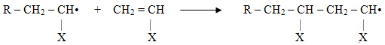

Termination
At some point, propagating polymer chain stops growing and terminates. This termination may be,
- coupling or combination
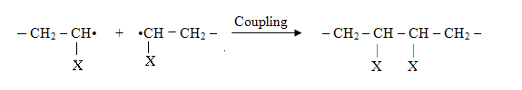

(ii) rarely by disproportionation
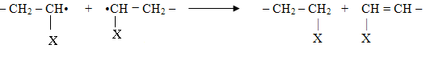

3. Discuss Coordination or Ziegler-Natta polymerization mechanism. (May 12, 15, Jan 13,16)
Ziegler-Natta polymerization mechanism
These are special type of coordination catalysts comprising two components.
Catalyst: catalyst consists of halides of transition metal, e.g. triethyl aluminium (AlEt₃).
Co-catalyst: co-catalysts are organo-metallic compounds, titanium chloride (TiCl₃).
Structure of coordination complex
When catalyst and co-catalyst components are mixed, aluminum alkyls act as electron acceptor and titanium halides are electron donor. This results in the formation of an electron-deficient bridge complex.
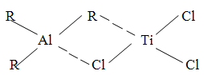

Cat – Z
Initiation
This complex now acts as active centre and monomer is attracted towards Ti–C bond.
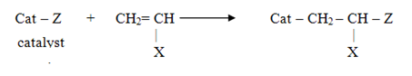

Propagation
With addition of a second monomer molecule, the monomer insertion is repeated. The orientation of substituent group of monomer is always taken from metal-ion, resulting in a stereo-regulated polymer.
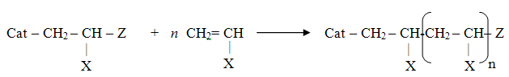

Termination
Termination takes place by addition of active hydrogen compound with regeneration of catalyst.
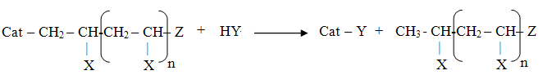

Application
This is used to prepare stereospecif0ic polymers.
Polypropylene, polyethylene and polydiene are prepared by this method

4. Differentiate thermoplastics and thermosetting plastics. (Jan 11, 13, May 11, 12, 14, 15, 16)
Thermoplastics resins | Thermosetting resins
(i) formed by addition polymerization  (ii) consist of linear long chain polymers with low molecular weights  (iii) polymer chains held by vanderwaals forces  (iv) weak, soft and less brittle  (v) soften on heating and harden on cooling in mould  (vi) fusible and can be remoulded  (vii) soluble in organic solvents.  E.g. Polyethylene, PVC, TEFLON and Nylons. | formed by condensation polymerization  consist of three dimensional network structures with high molecular weights  chains linked by strong covalent bonds  strong, hard and more brittle  do not soften on heating in the mould  not fusible, cannot be remoulded  insoluble in organic solvents.  E.g. Bakelite, silicones and polyesters.

5. Give the preparation and uses of Bakelite and Butyl rubber. (Jan 13, 14, 16, May 14)
Preparation of Bakelite
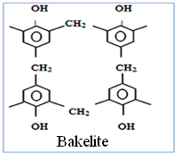
Bakelite is obtained by condensation polymerization of phenol and formaldehyde in presence of acid or base catalyst.
Steps in preparation of Bakelite
Step 1 – Formation of Methylol derivatives
Step 2 – Novolac formation Structure of
Step 3 – Resole formation Bakelite
Step 4 – Bakelite production
Uses
- for making moulded articles like telephone parts, cabinets for TV
- for making plugs, switches, switch boards and heater handles

Preparation of Butyl rubber
Butyl rubber is made by copolymerization of isobutene with isoprene.
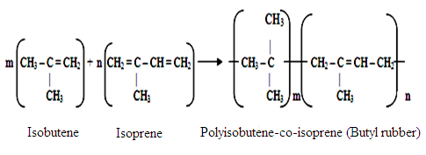

Uses
- for cycle and automobile tubes and automobile parts
- conveyor belts for food and other materials.

6. Explain Vulcanization of rubber and its advantages. (Nov 11, May 11, 12, 14, 16)
Vulcanization
To improve the properties of rubber, it is compounded with chemicals like sulphur.
Process
The process consists in heating raw rubber with sulphur to 100-140 ºC.
Added sulphur combines chemically at double bonds of different rubber springs.
Extent of stiffness of vulcanization rubber depends on the amount of sulphur added.
Example
Tyre rubber contain 5% sulphur and battery case rubber contain 30% sulphur and vulcanite or abonite or hard rubber contains about 32% sulphur.

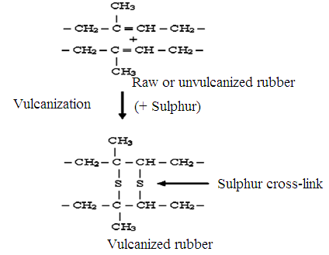
Reactions

Advantages of vulcanization
- has good tensile strength, useful temperature range of -40 to 100 ºC and has slight tackiness
- article returns to original shape when deforming load is removed (resilience)
- possesses low water-absorption tendency and higher resistance to oxidation
- has higher resistance to wear and tear and has better electrical insulation
- resistant to petrol, benzene, fats and oils and easy to manipulate to produce desired shapes.

7. Discuss the types and applications of conducting polymer. (Nov 11, Jan 13, May 14, 16)
Conducting polymers
Most of polymeric materials are poor conductors of electricity, because of non availability of large number of free electrons. Now, polymeric materials synthesized which possess electrical conductivities on par with metallic conductors. Such polymers are called conducting polymers.
Types of conducting polymers
- Intrinsically conducting polymers (ICP)
It is a polymer whose associated groups consist of delocalized π electrons pair.
E.g. : polyphenylene, polyaniline and polypyrrole.
- Doped conducting polymer
It is obtained by exposing a polymer to a charge transfer agent in either gas phase or in solution.
The conductivity of ICP can be increased by creating either positive or negative charges on the polymer backbone by oxidation or reduction. This technique is called doping.
(a) P-doping: treating ICP with a Lewis acid. e.g. I₂ and PF₆.
(b) N-doping: treating ICP with Lewis base. e.g. Li and FeCl₃.
(iii) Extrinsically conducting polymers
Conductivity is due to presence of externally added ingredient in them.
(a) Conductive element filled polymer: polymer filled with conducting elements such as carbon black and metal oxides.
(b) Blended conducting polymer: blending polymer with conducting polymer either by physical or chemical changes.
(iv) Coordination conducting polymers (inorganic polymers)
It is a charge transfer complex containing polymer.
This is obtained by combining metal atom with poly dentate ligand.
Applications of conducting polymers
- In rechargeable batteries and in optically display devices.
- Wiring in aircrafts and aerospace components and in telecommunication systems.
- In coatings for clothing and in electromagnetic screening materials.
- In electronic devices like transistors, in solar cells and in drug delivery system for human body.

8. Discuss Injection moulding and Extrusion moulding techniques. (Jan 14, May 14)
Injection moulding
Injection moulding is mainly applicable to thermoplastic resins.
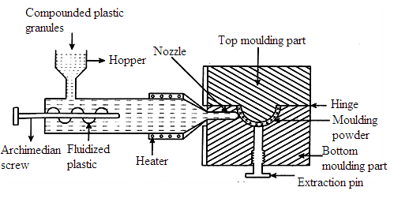
Diagram

Process
In this, moulding plastic powder is fed into a heated cylinder.
It is then injected at a controlled rate into a tightly-locked mould.
This is kept cold to allow hot plastic to cure and become rigid.
Heating is done by oil or electricity.
Advantages
- Mainly used for moulding of thermoplastics.
- High-speed production and low mould cost and finishing cost.
Disadvantage
Large number of cavities cannot be filled simultaneously.
Extrusion moulding
Extrusion moulding is used mainly for continuous moulding of thermoplastic materials into articles of uniform cross-section like tubes, rods, strips and insulated electric cables.
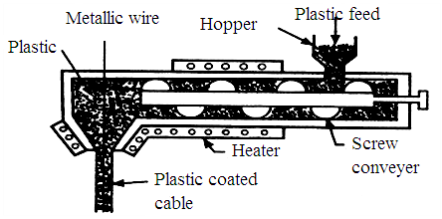
Diagram

Process
Thermoplastic ingredients are heated to plastic condition.
It is then pushed by means of screw conveyor into a die of article to be manufactured.
Here the plastic mass gets cooled, due to atmospheric exposure.
A long conveyor continuously carries away the cooled product.
Advantages
- For making films, pipes, cables and hoses.
- Sheets for vacuum forming, mixing operations and re-working of waste materials.

